Danish Senior Open 2020
Program

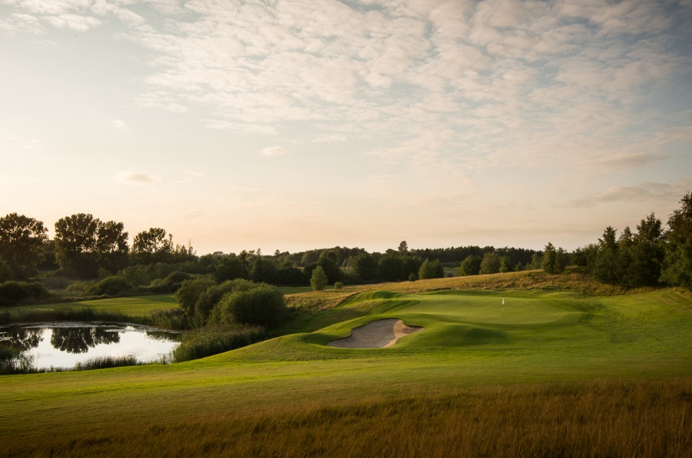

Monday July 20th. - Tuesday July 21th. – Wednesday July 22th: One free practice round can be booked.

Thursday July 23th: 1. Round will start at 12:00. The loops will be C – B.

Friday July 24th: 2. Round will start at 08:00. The loops will be C – B. Cut will take place after this round.

Saturday July 25th: Final round will start at 08:00. The loops will be C – B.
Around 15:30: SEGAF will be the host for a small refreshment. Price ceremony will take place at the Lakeside right after last players has finished their round.

